**EXPERIMENT 05**

**AIM: IMPLEMENTATION OF SIMPLE CALCULATOR AND DEPLOYMENT OF SAME.**

**OUTPUT:**

**ON EMMULATOR**

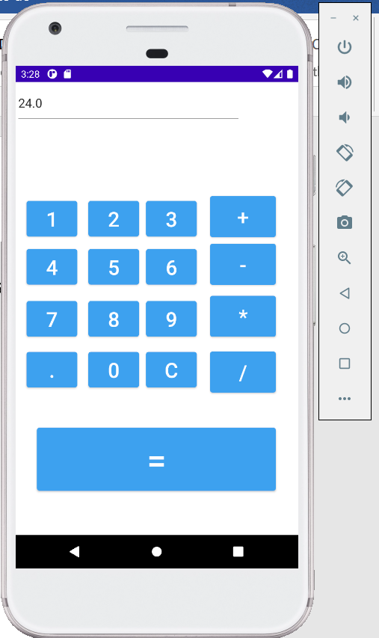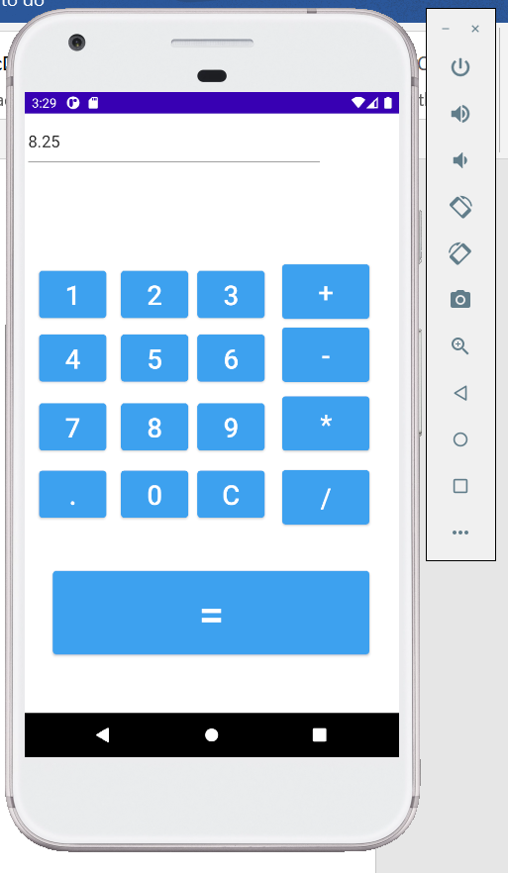

**ON REAL DEVICE**

